Project 2 Notes

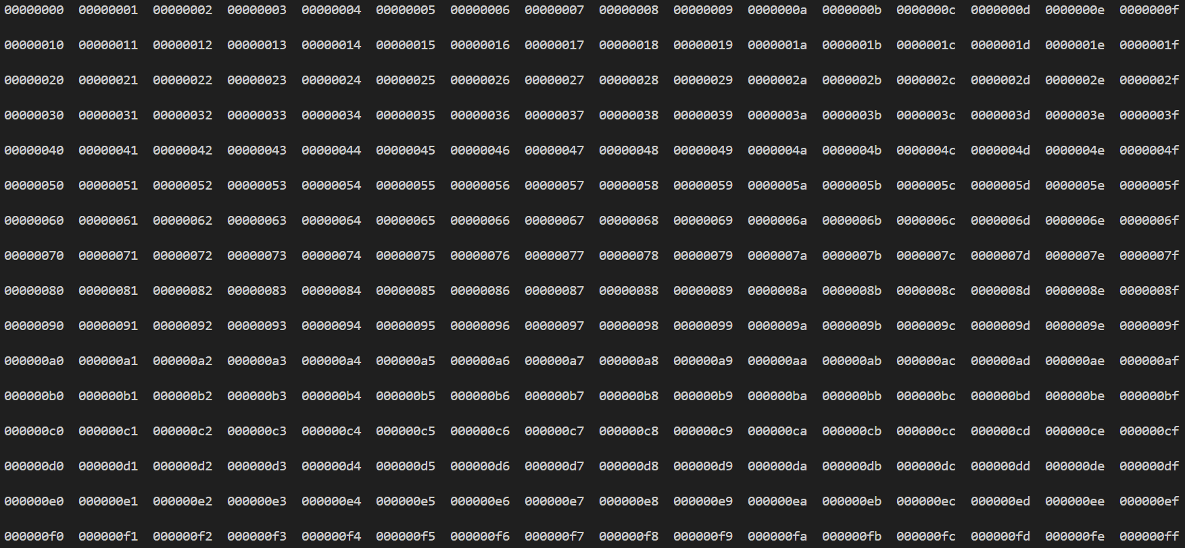
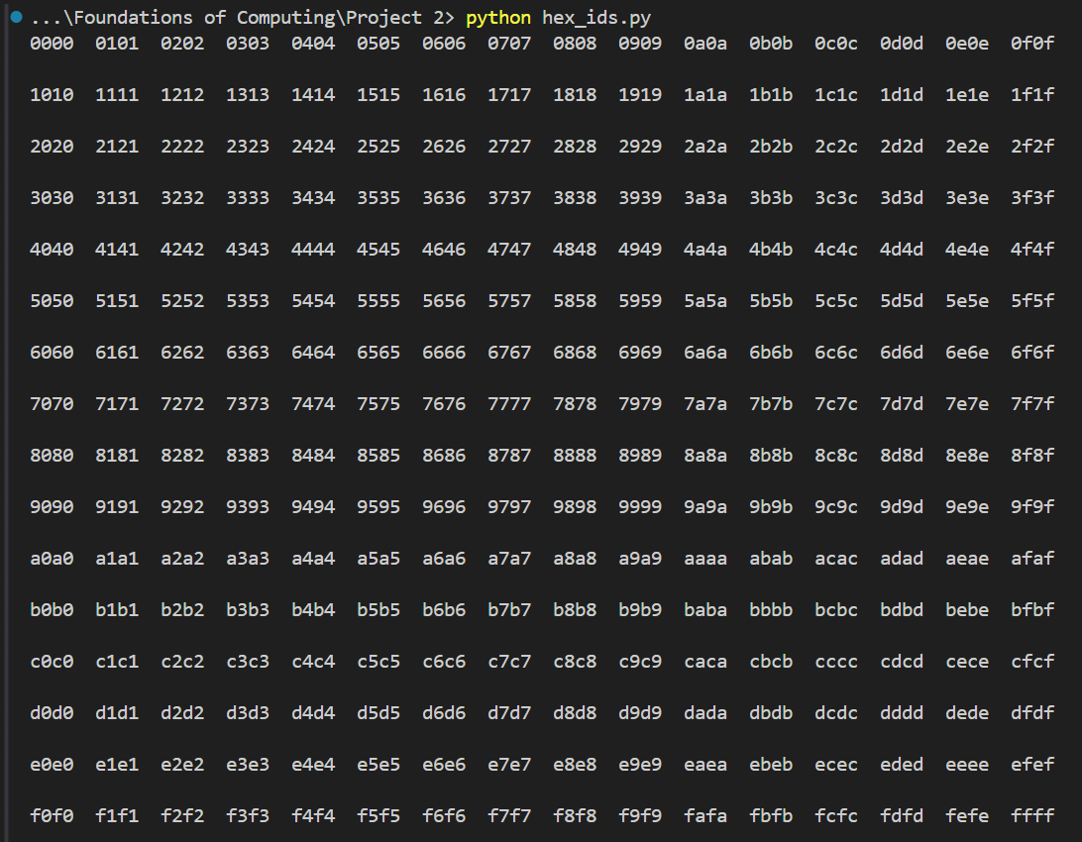
What each digit represents:
 |  | favourite colour  Mod4 this | social media  Mod4 this

Social media alternating columns, repeat every 4
Favorite colour alternating rows, repeat every 4
Accessory alternating columns (groups of 4)
Hair type alternating rows (groups of 4)

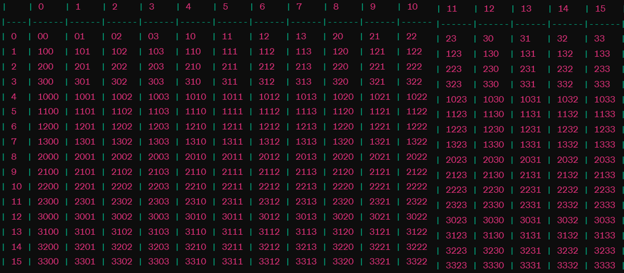
Hairstyle / Cap | Favourite colour | Accessory | Social media

